

SUPFile-PROJECT

***Class* Group Project**

**4PJT-SUPFile**

Delivery

SUPFile User Manual and Deployment Documentation

Version 1.0

Last update: 08/06/2018

Use: Users

Welcome to use our application, If you have any question, please read it. If you haven’t solved the problem after reading the document,don’t hesitate to contact us.

# OPERATING ENVIRONMENT

1. The server is Glassfish
2. The database is MYSQL
3. The operating system is Linux
4. Needn’t worry about data missing, the HA backup run on linux.
5. (1)The web side selects google chrome

(2)Android runs on android system.The system version is required to be over 4.0. The screen resolution of 720*1080 and 1080*1920 is supported.

# Deployment ManUal

Based on the environment above , client can choose to deploy the web application according to this deployment manual.

1. Install jdk

We use jdk package jdk-8u171-linux-x64.tar.gz for our project and you can choose a different package in the official website : <http://www.oracle.com/technetwork/java/javase/downloads/index.html>.

**Steps :**

**mkdir -p /usr/lib/jvm**

**tar -zxvf jdk-8u171-linux-x64.tar.gz -C /usr/lib/jvm**

**nano /etc/profile**

add these in this file :

export JAVA_HOME=/usr/lib/jvm/jdk1.8.0_171

export JRE_HOME=${JAVA_HOME}/jre

export CLASSPATH=.:${JAVA_HOME}/lib:${JRE_HOME}/lib

export PATH=${JAVA_HOME}/bin:$PATH source /etc/profile

**source /etc/profile**

**java -version**

1. Install glassfish

You can download glassfish in the website : <https://glassfish.java.net/>

We use glassfish-4.0-ml.zip package for our project.

Steps :

Unzip glassfish

cd glassfish4/bin

./asadmin start-domain domain1

Access glassfish server admin console by <http://127.0.0.1:4848>

1. Install my sql

**wget** [**http://repo.mysql.com/mysql57-community-release-el7-10.noarch.rpm**](http://repo.mysql.com/mysql57-community-release-el7-10.noarch.rpm)

**sudo rpm -Uvh mysql57-community-release-el7-10.noarch.rpm**

**yum install -y mysql-community-server**

**service mysqld start**

**grep 'temporary password' /var/log/mysqld.log**

**service mysqld restart**

**mysql -u root -p**  login mysql

then create table fileup

add user fileupUser and grant priviledge

CREATE DATABASE `fileupv` CHARACTER SET utf8 COLLATE utf8_general_ci;

CREATE USER 'fileup_User'@'localhost' IDENTIFIED BY 'root';GRANT ALL PRIVILEGES ON *.* TO 'fileup_User'@'localhost' IDENTIFIED BY 'root' WITH GRANT OPTION MAX_QUERIES_PER_HOUR 0 MAX_CONNECTIONS_PER_HOUR 0 MAX_UPDATES_PER_HOUR 0 MAX_USER_CONNECTIONS 0;GRANT ALL PRIVILEGES ON `fileup`.* TO 'fileup_User'@'localhost';

GRANT ALL PRIVILEGES ON `fileup`.* TO 'fileupUser'@'localhost'WITH GRANT OPTION;

1. Copy mysql-connector to the lib of glassfish
2. Create in glassfish admin console a jdbc resource pool and a jdbc resource that connect to the table you just created.
3. Deploy the web application in the admin console by deploy the war file of the project.

# web application SpECIFICATION

## 2.1 Home PAGE

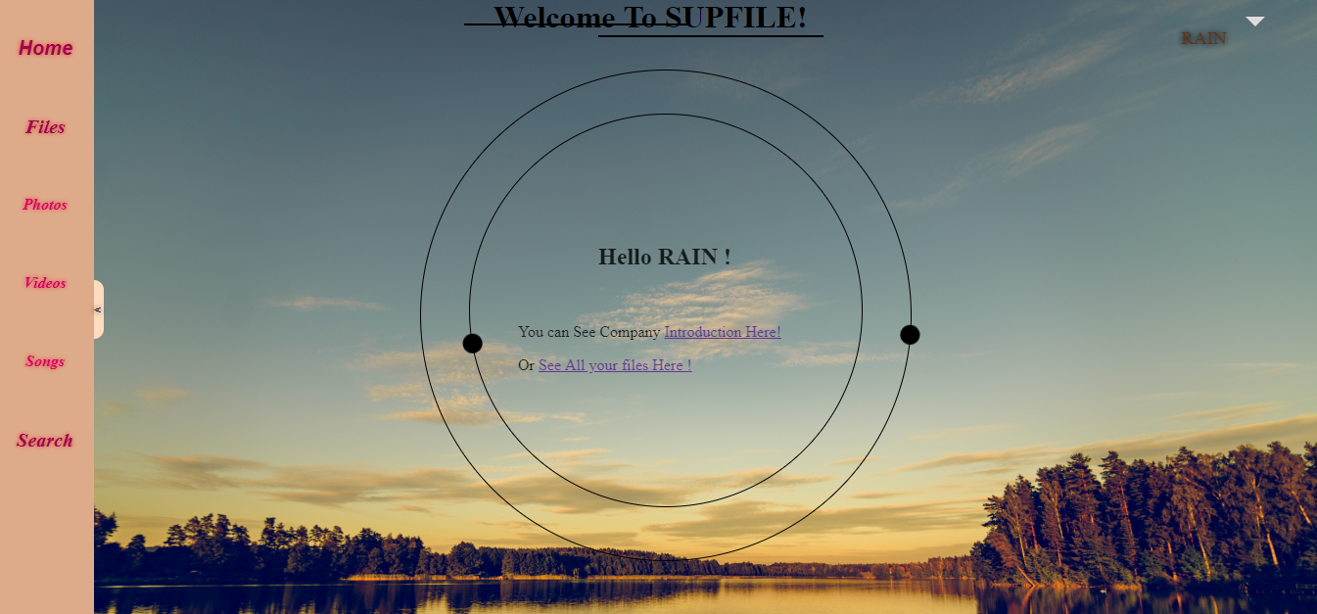

1.About our campany

You can choose “Introduction of Our Company” to know our company from company profile,technical file and our team. Press back to return.

(1)company profile

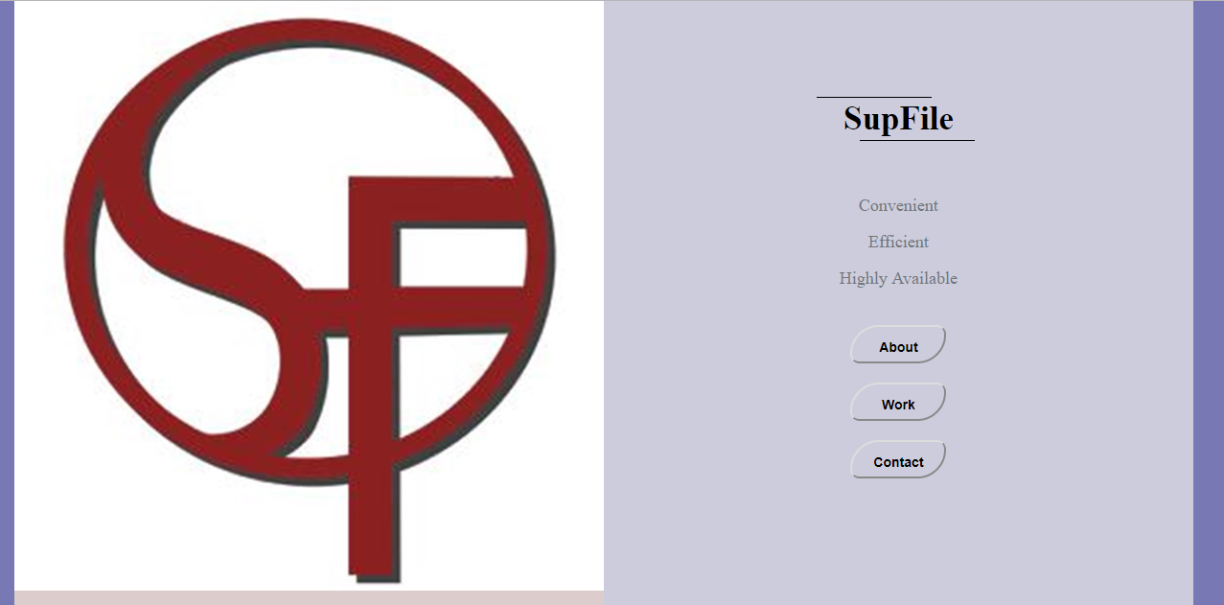

(2)technical file

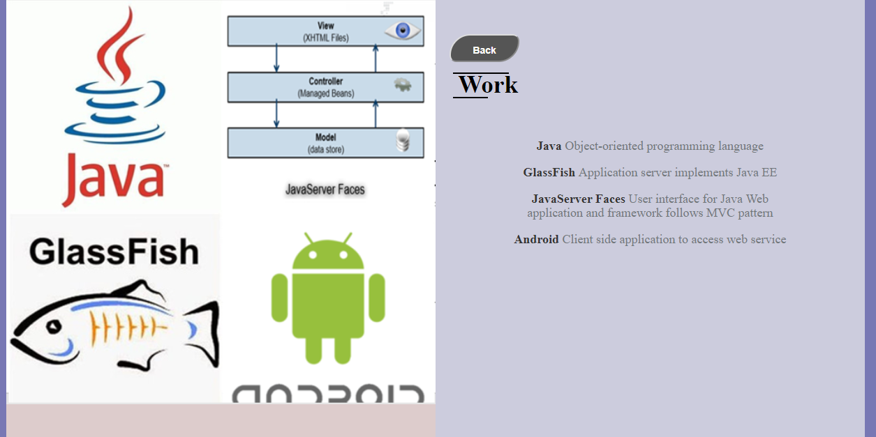

2.register

If you are first time to use this application,you must have you own account.So you can press”register” in the upper left corner or”register here” in the middle of the screen.

IF you have google or facebook you can login directly.

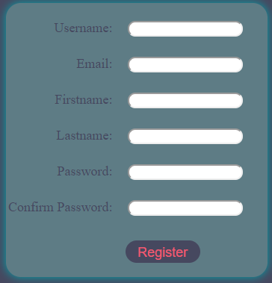

3.login

If you already have account,then you can use it to use our application.

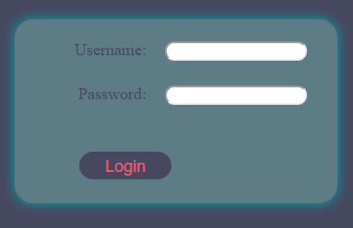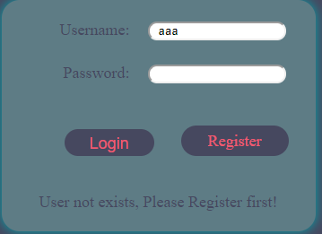

(If you write wrong account, system will remind you that if you need to register.)

## 2.2 APPLICATION INTERFACE

1. Check and edit your personal information in the top right corner.

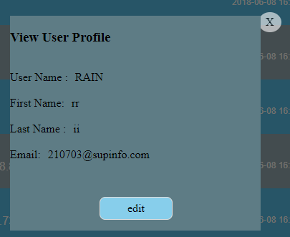

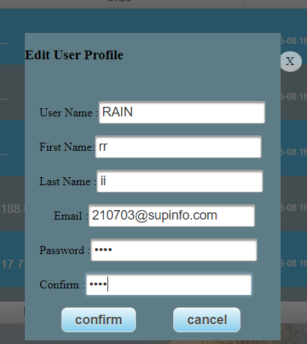

1. Upload files.

You can click”choose file” to choose and uoload the files or songs or videos .Or you can drag the file directly from the file system here.

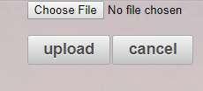

1. Browse files
2. On the left is the navigation bar,you can clearly find upload data according to different categories: Files,Photos,Videos,Songs. 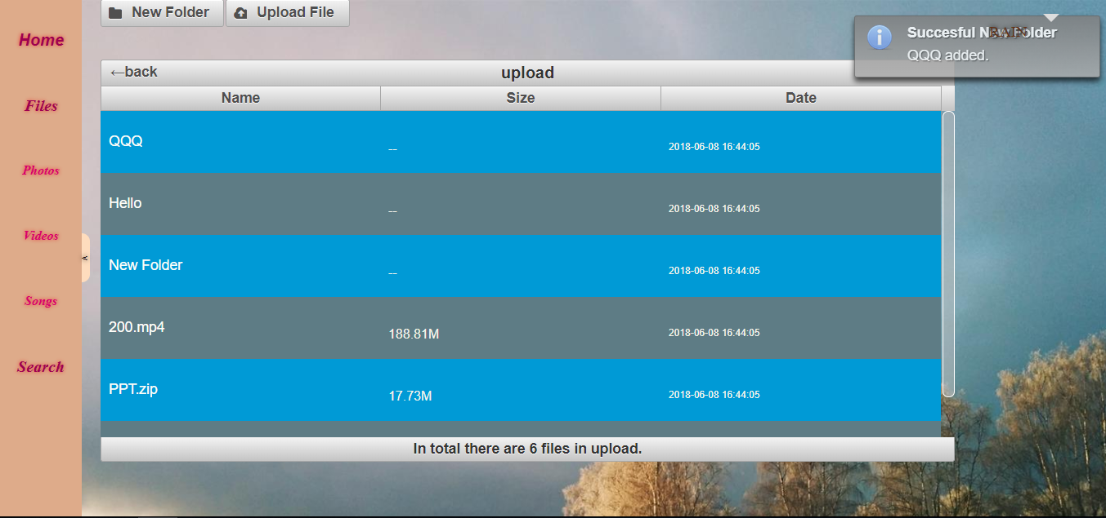
3. The app supports online preview. Just need to doubol click file name.

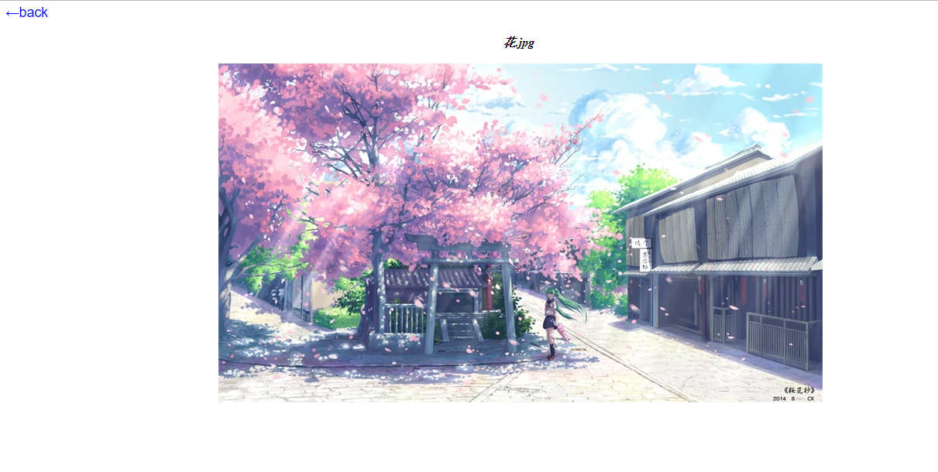

1. Create folder.

Click “New Folder”button,it wil create a new folder named” New Folder”.You can change the name.Attention please: at the same level directory doesn’t allow the nuptial folder,otherwise you will receive prompt message”unsucessful”.

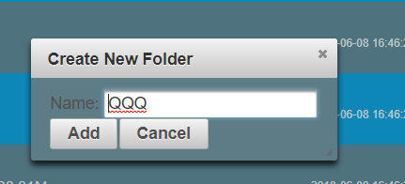

1. Edit files.

When you right click the file or folder name,you can choose to copy,cut,rename,delete,download.And right click the page blank position can paste files or folders.

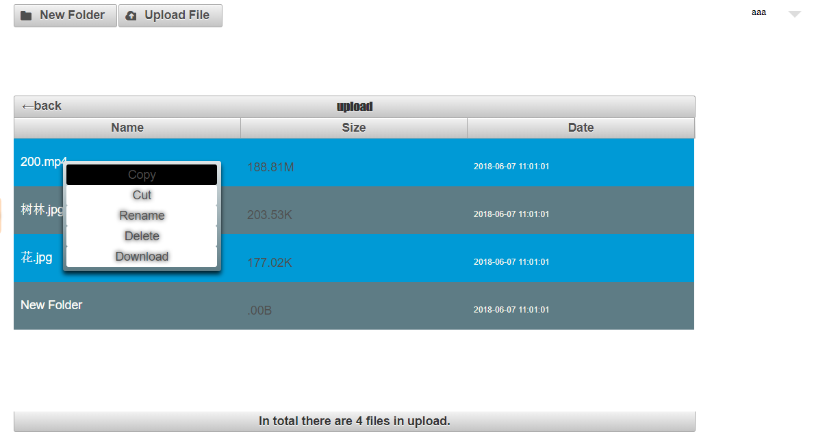

To rename a file:

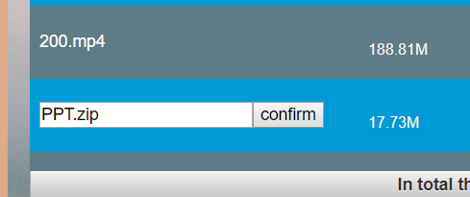

To paste a file:

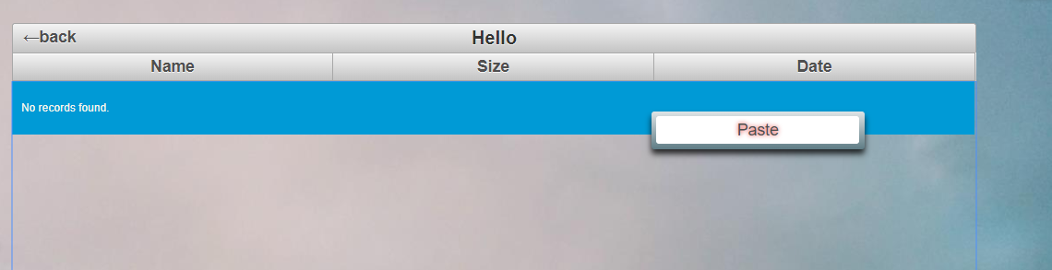

To search a file:

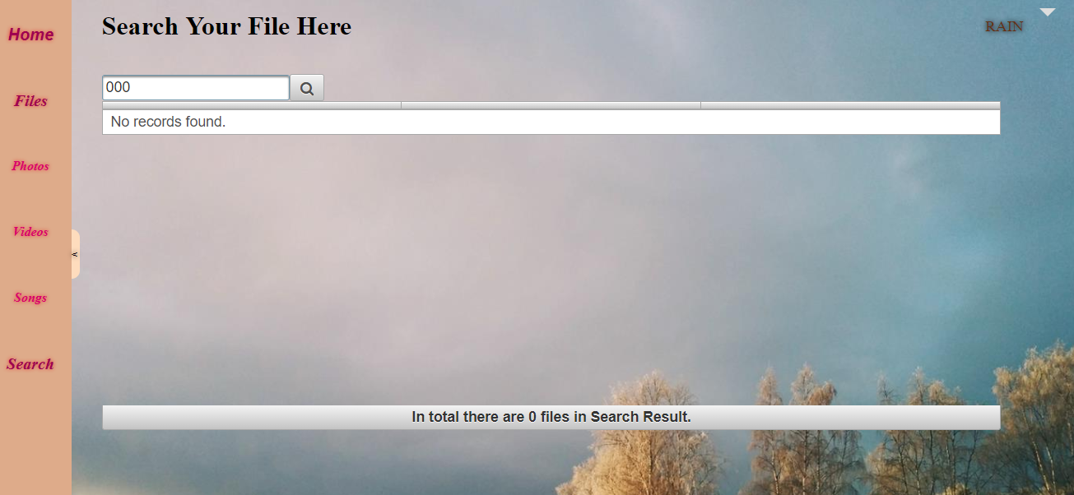

# 3 ANDROID application SpECIFICATION

Register interface:

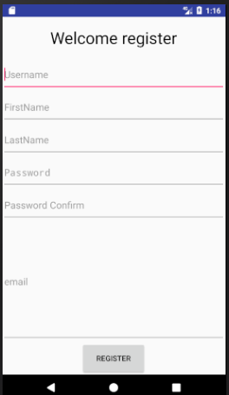

Login interface:

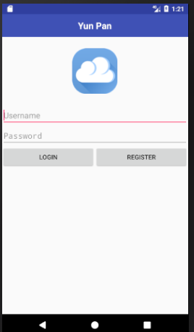

File display page:

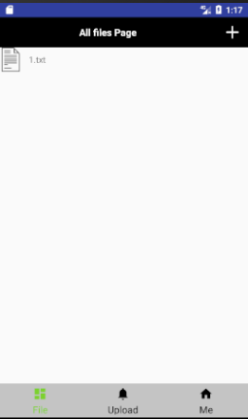

In this page, user can see all their files and add folder or rename filename.

User profile page:

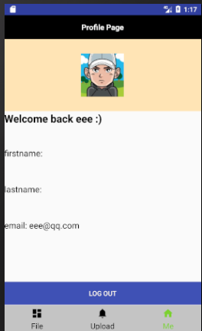

In this page, users can see all their personal information.